The Auckland Zionist Society

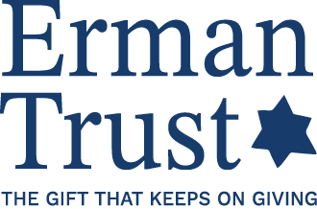

REPORT BACK FORM

This form must be completed and submitted by 31 January for those who went on annual programmes and within a month of returning to New Zealand for all others.
Please email a copy to ermantrust@gmail.com

Website: www.ermantrust.co.nz

Telephone: 021 958904 (David Kranz, Chairperson)

1. PERSONAL INFORMATION
1. Family Name:
2. Given Names:
3. Date of Birth:
4. Full Address:
5. Telephone: Home
Mobile
6. Email:
8. Date this form is submitted:
2. PROGRAMME INFORMATION
- Full name of institution in Israel:
- Title of programme/course/ project:
- Date programme began in Israel:
- Date programme ended in Israel:
- Date you returned from Israel:
3. EXPERIENCE IN ISRAEL
      - In what way did your experience contribute to your personal development and Jewish identity? (50-100 words)

      - To what extent did the experience meet your expectations? How would you rate the quality of the programme? (50-100 words)

4. CONTRIBUTION TO THE JEWISH COMMUNITY IN NEW ZEALAND
- In what way have you contributed to the Jewish community since you returned from Israel? (50-100 words)

- In what way will you contribute to the Jewish community for the balance of your commitment to the Erman Trust? (50-100 words)

Thank you for completing this form.

